Hard-edge minimal painting: Saliba Douaihy’s New York era
When Saliba Douaihy arrived in New York in 1950, his painting repertoire was classic. After his four years of training under Habib Srour in the art of frescos and his Parisian education at the Academy of Fine Arts, he painted the frescoes of the Diman Church and spent the remainder of his time in his hometown, Ehden, observing and painting the holy valley of Kadisha. The fifties mark his arrival in the realms of geometric abstraction, and subsequently into minimal art. In the past, the work of Saliba Douaihy has been understood as that of an artist who is obsessed with Lebanese landscapes – constant representations of the “colors of the Middle East” (Tarnowski, 2013). As I will show here, what has been so far overlooked about this artist is that his art style and subject matter completely changed during his New York era (post-1950), evolving into a new technique of abstraction in its own right.
The Lebanese journalist and art historian Charbel Dagher, in his article Saliba Douaihy ou le Voyageur Immobile (1991), reads the painter’s progression as a single thread – repeatedly painting the same structures while progressively simplifying them. In this transition from figuration to abstraction, he finds a consistent theme in his painting since the thirties: a large colored space, bounded by narrow stripes of different shapes and intensities. Dagher attributes this paradigm to the constant representation of the Kadisha Valley. This is the sight the artist grew up with, a sacred place in Lebanon where Maronite monks found shelter in times of persecution. The scholar explains that throughout his artistic career, Douaihy has always retraced his steps back to this valley, by simplifying this horizontal space bordered by an abrupt tilt. He introduced raw color and straight lines as a means of filtering and purifying the sight in his memory – this is analogous to “returning to a primal code of communication after having written and spoken for all of his life” (Dagher, 1991).
Dagher explains that the ultimate outcome of Saliba Douaihy’s long travels to Europe and the United States was in fact an artistic journey to paint the Kadisha valley in its purest, truest form. Hence the title of his essay: the immobile traveler, in the sense that Douaihy painted Kadisha - or more generally traditional rural Lebanese scenery – wherever he went. This analysis, however, entails a paradox: how can Douaihy, as an artist, be immobile, stationary, or static, if his art itself implies movement? A distinction needs to be made between the passive act of seeing a scenery or traveling, and the active exercise of painting. Indeed, the same line that binds Douaihy to a supposedly unchanging scenery makes the dynamism his movement an undeniable fact. The act of tracing a line itself requires motion: a precise, “one-time” stroke that utilizes his arm, if not his entire upper body to perform. And since painting requires the artist to be active – to “do” the act of painting – he cannot simultaneously be a passive, immobile traveler. Perhaps Douaihy isn’t reminiscing about the colors of Lebanon by depicting the same scenery over and over again.
In order to have a complete reading on Douaihy’s New York era, the approach of biographism is insufficient on its own. In essence, this statement is similar to Anne Wagner’s idea about Lee Krasner in Lee Krasner as L.K. (1989). Where L.K’s art could hardly be appreciated as long as she was seen as “Mrs. Jackson Pollock”, our reading of Saliba Douaihy as “the painter from a little Christian village in Lebanon” leads to an incomplete appreciation. Instead of trying to associate the painter to a gender identity, an ethnic background or a region of origin, the artworks must be analyzed in a formal sense. Although it should not be entirely ignored, Douaihy’s biographical elements should be dissociated from his New York era art.
In his untitled pieces dated between 1959 and 1967, Douaihy paints a dominant hue of bright color, along with oblique, thin bands of different colors along the left or right edges of the painting. Along with his move towards abstraction, Douaihy’s arrival in New York marks his shift from the use of classical oil on wood or oil on canvas to a new artistic support: acrylic on canvas. The shapes are geometric, made up of straight lines, and the acrylic allows for a complete delimitation of the colors rather than a bleeding-over or an overlap. Furthermore, the colors are distinct primary colors – there are no nuances of the same color that could indicate volume or depth. Douaihy is experimenting with an all-over field of color. In adapting his new technique with acrylic, the painter introduced two-dimensional geometric shapes (more specifically a dominant central shape and smaller ones in the periphery) in dense colors and distinct edges.
Saliba Douaihy produced a large number of acrylic paintings with the similar template, only varying the particular colors, canvas dimensions and sizes of the flat geometric objects. The previous readings of this theme attributed this period to Douaihy’s “attempt to paint a purer, simpler Kadisha valley”. Certainly, the red and blue hues of the central shape can be associated to a day-and-night cycle of the valley’s sky, but the geometric objects that would logically become the ground are in fact always vertical rather than horizontal. The idea that the painter only has Lebanon on his mind is also complicated by the fact that he shared correspondences with Helen Frankenthaler (in 1968, the two received an award at the Pennsylvania Academy Annual). Many similarities can be found between Douaihy’s Grove (1962) and Frankenthaler’s Canal (1963). They both follow the logic defined by Michael Fried in his essay Three American Painters (1965) as Post-painterly abstraction. The two artists place a heavy importance on composition, on the basic physical elements of the painting. The paint itself is used as an indicator of the gestural, while maintaining a logic of surface. The technique consisted in staining the canvas to create paintings whose color was inseparable from the canvas, ultimately resulting in a tension between the undeniable flatness of the picture plane and the thin shapes and lines that seem to “emancipate” out of the picture plane. I have established that Douaihy, like Frankenthaler, follows the logic of post-painterly abstraction. Fried later in his essay expounds the notion that by this post-painterly abstraction, the artist is lead to reject any form of mysticism - or reference to the external world. Therefore, Douaihy couldn’t have worked to attain post-painterly abstraction while at the same time having as a telos the simplified or pure Kadisha valley: by definition post-painterly abstraction cancels representation from the picture plane.
Detaching our reading of Douaihy’s painting from his origins allows for a more formal appreciation. The conclusions that he reached after studying geometric abstraction for five years while in the United States are clear: he was experimenting with new methods of painting – in this case using at once a “theme” and a “process” – to measure the capabilities of abstraction. In his book The Art of Saliba Douaihy (2016), Jean Sader mentions that Douaihy read works by Immanuel Kant while taking a course in aesthetics at the New School of Social Research in New York in 1961. From Kant he derived an interest to reduce all elements to their most basic form. Clement Greenberg refers to Kant as the first real Modernist in his essay Modernist Painting (1960), in that Kant introduced the notion of self-criticism. Greenberg explains that in modernist painting, the viewer is made aware of the flatness of the picture plane before understanding what it contains. In Douaihy’s “hard-edge minimal” style, this simplification of the picture plane into flatness can be seen in both form and color. The relationships between large and small shapes, angular and curved lines, brilliant and subdued colors, acute and obtuse angles seem to provide an infinite range of variations within the strict parameters the artist has set for himself. Moreover, the presence of the sliver-like shapes at the perimeters is the key to Douaihy’s system. While the eye is dominated by the central color plane, the viewer focuses ever-so slightly on them, and back the center again. This “va-et-vient” motion leads to the “infinite space” dimension of Douaihy’s painting.
Douaihy’s infinite abstract space rests solely on the presence of the edge-forms, without which the organization of the whole painting is lessened. His New York era artworks are all acrylic on canvas, painted with relatively big brushes and sometimes even using his hand directly. They are untitled – because they have no subject – and embody a triumph of the surface plane, an ode to color, a celebration of vision, a eulogy of life (Sader). When seen outside of the scope of depicting Kadisha valley, it becomes clear that Douaihy has constructed an abstract style that is at the intersection between Mondrian and Rothko. Even more so, neither does Douaihy’s painting exclude curved lines, nor does it restrict itself to a set of colors: his art allows for infinite configurations.
Saliba Douaihy’s New York era can be defined as an attempt to eliminate all points of reference anchored in reality from his work. He developed a new artistic language based on the expressive possibilities of color, line, and gesture. More than just odes to his past or to a distant memory of the Kadisha valley, Douaihy’s art of the fifties and sixties signal a complete shift in his artistic method: his hard-edge minimal painting style is a deliberate act to break the illusion of pictorial space and bring painting into the world of the viewer.

Bibliography:
- Dagher, Charbel. Reportage couleurs: Saliba Douaihy ou le voyageur immobile. Arabies (1991)
- Greenberg, Clement. Modernist Painting. The University of Chicago press (1960)
- Rosenberg, Harold. The American Action Painters. The Tradition of the New (1952)
- Sader, Jean. The art of Saliba Doueihy. Fine Arts Publishing (2016)
- Tarnowski, Stefan. Journeys through our heritage: Revisiting modern Lebanese artists. Art and AsiaPacific (2013)
- Wagner, Anne. Lee Krasner as L.K. Representations (1989)
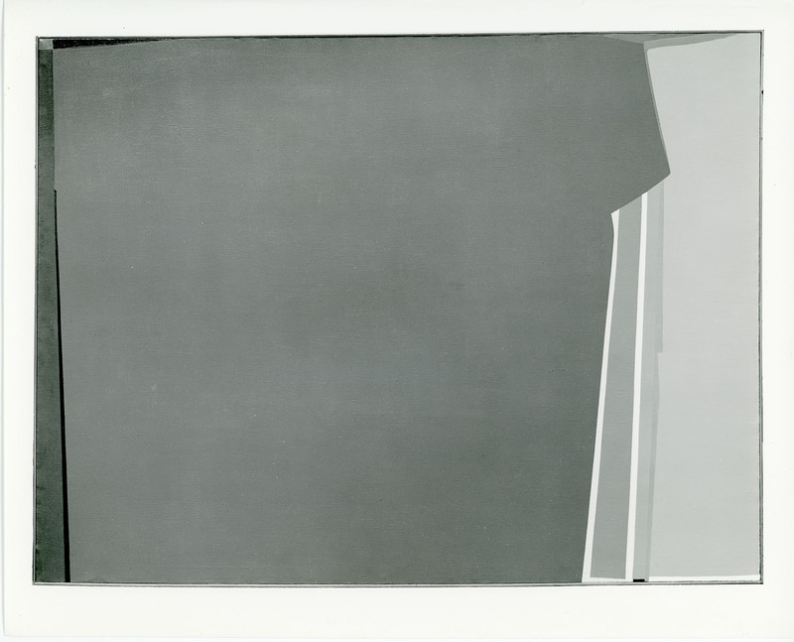
Saliba Douaihy, Grove (black and white photograph) (1960)

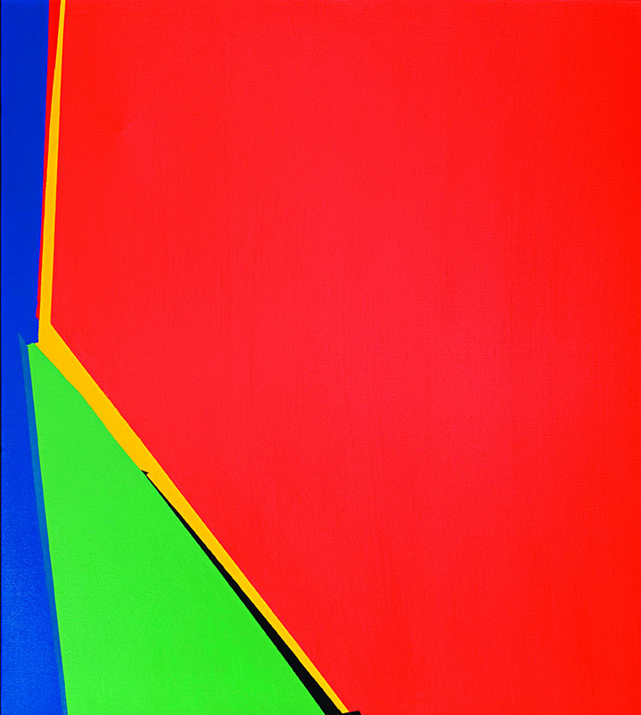
Saliba Douaihy, untitled (Acrylic on Canvas 100 x 90 cm) (1963)


Saliba Douaihy, untitled (Acrylic on Canvas 103 x 103 cm) (1965)


Saliba Douaihy, untitled (Acrylic on Canvas) (1966)
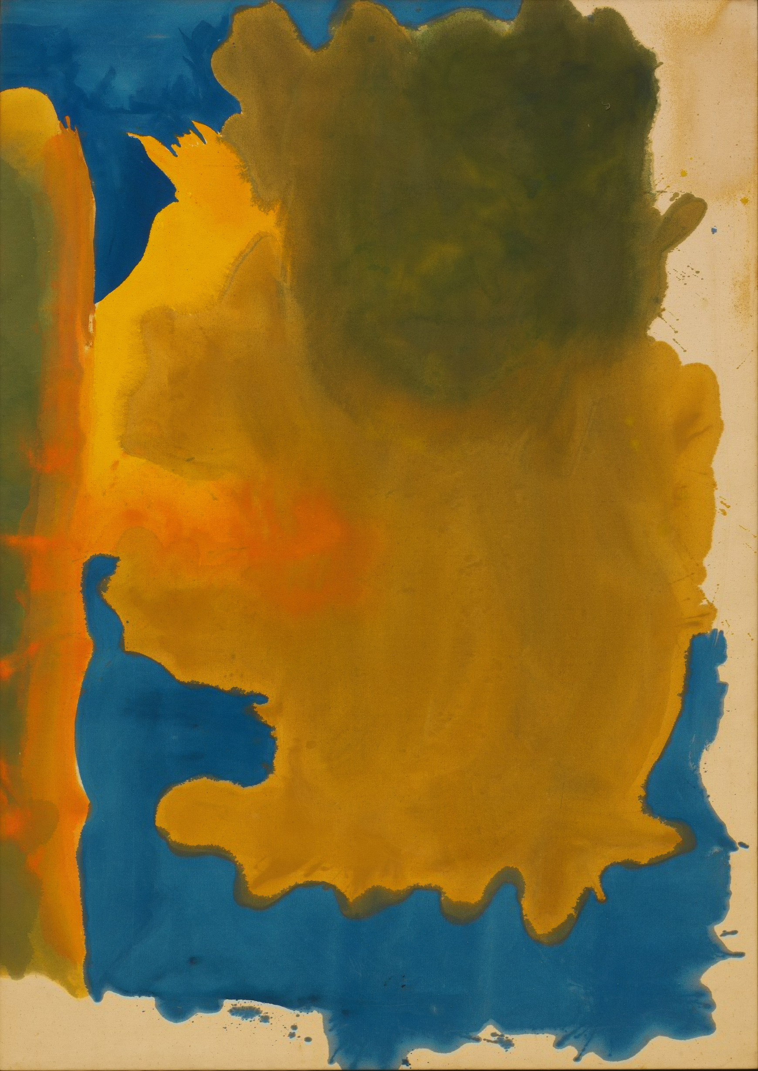
Helen Frankenthaler, Canal (1963)

